Kearney Area COVID report

Background
The Two Rivers Public Health Department (TRPHD) covers 7 counties in central Nebraska, reaching 97,132 people who live and work in the health district spread across roughly 4663 square miles. Over three quarters of residents live in Buffalo and Dawson county, a tenth live in Phelps county, and the remaining 15% is spread somewhat comparably among the four counties of Kearney, Harlan, Franklin and Gosper in decreasing order of population. The largest urban areas are Holdrege (~5439 people), Lexington (~10,024 people), and Kearney (~33,835 people), meaning that over half of the residents of TRPHD live in three urban areas, and over a third live in Kearney city alone.

Methods
To better understand the course of the COVID-19 pandemic in these three cities, we created ‘urban areas’ that included both the city and its surrounding towns. We included all towns within 20 miles of Kearney city, 15 miles of Lexington and 10 miles of Holdrege within each city’s urban area.

Thus “Kearney area” includes Kearney city as well as Elm Creek, Pleasanton, Amherst, Riverdale, Gibbon, Shelton and Axtell.
“Lexington area” includes Lexington city as well as Overton, Johnson Lake and Cozad.
“Holdrege area” includes Holdrege city, Loomis and Funk.

In the first edition of this document, we will look at the course of the COVID-19 pandemic in TRPHD, identify two distinct phases and focus on the second phase, largely driven by the continuing rise in newly detected cases in Kearney area. Analyzing data from the previous four weeks, we will try to explore positivity rates and absolute numbers in specific age groups to better understand risk and transmission dynamics

Overview
- Figure 1 (a) describes the COVID-19 pandemic for all counties in TRPHD from April 1 2020 to October 6, 2020. Figure 1 (b) describes the cases in Lexington and Kearney areas during the same period. Two clear phases are visible: an initial outbreak in Lexington (April-May) that subsided by early June and a more gradual but steady rise in cases mostly in Kearney that began mid- July and continues into October.
- Figure 2 describes cases in Kearney and Lexington from Sep 9 – Oct 6 (1 month); the continuing increase in daily cases in Kearney can be clearly observed.
- Table 1 describes the persons tested, positive cases and positivity rate by gender and city of residence of all persons tested between Sep 6 – Oct 6 in Kearney area. The city of Kearney accounted for 87% of all persons tested and 82% of all positives in Kearney area during this time period. The positivity rate of 17% in Kearney area is higher than that of entire TRPHD for the past month (15%).

Fig 1(a) (below) describes the 7-day rolling average of all COVID-19 cases in TRPHD from April 1- Oct 6, 2020
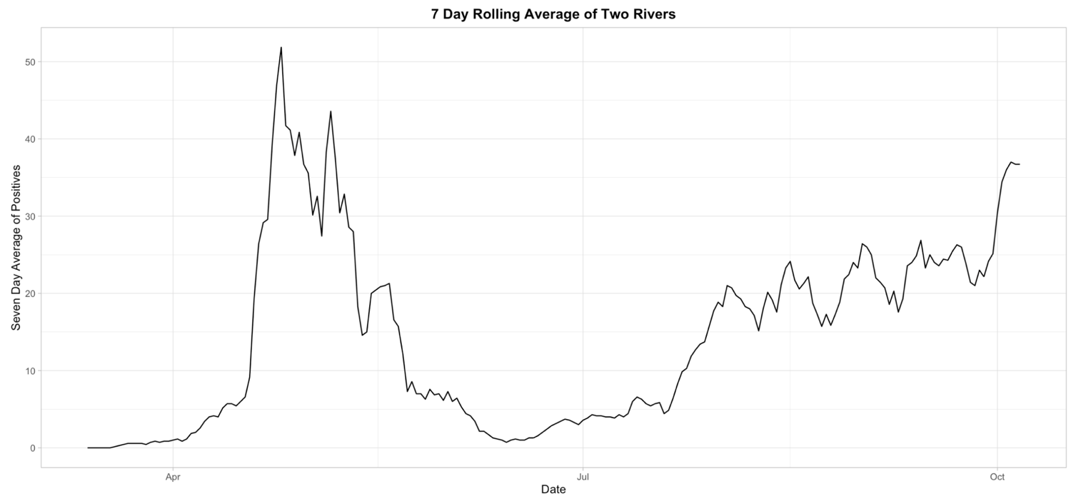

Fig 1(b) (below) describes the 7-day rolling average of all COVID-19 cases in Kearney and Lexington areas from April 1- Oct 6, 2020
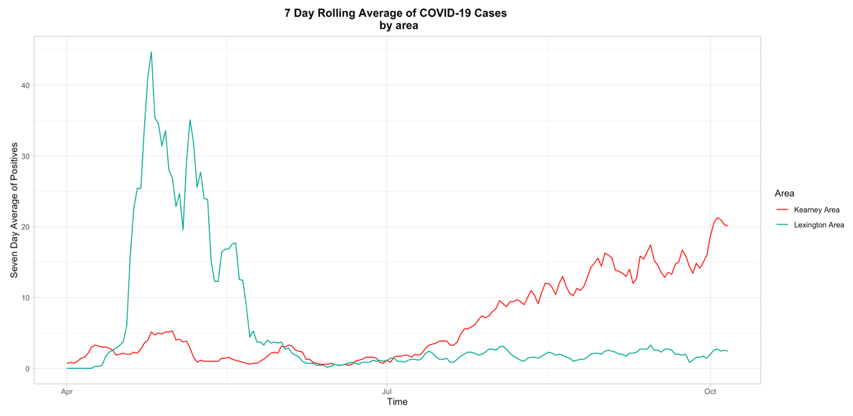

Fig 2 (below) describes the 7-day rolling average of all COVID-19 cases in Kearney and Lexington areas from Sep 6 - Oct 6, 2020
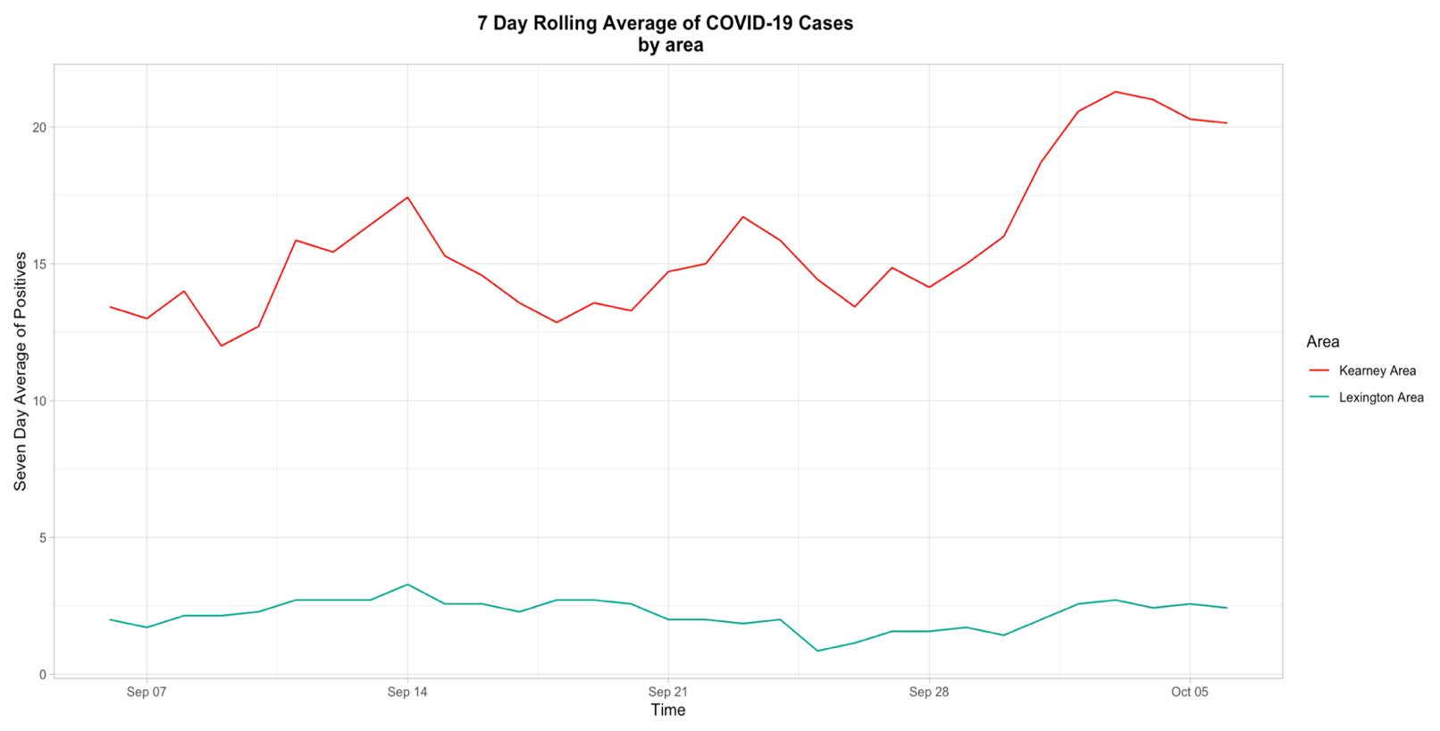

Table 1: Persons tested in Kearney area by gender and city of residence: Sep 6 – Oct 6
 | Persons tested | Positive results | Positivity Rate
City of Residence
Amherst | 22 | 7 | 31.8%
Axtell | 95 | 10 | 10.5%
Elm Creek | 51 | 8 | 15.7%
Gibbon | 90 | 27 | 30.0%
Kearney | 2440 | 389 | 15.9%
Pleasanton | 27 | 10 | 37.0%
Riverdale | 17 | 8 | 47.1%
Shelton | 64 | 14 | 21.9%
Total | 2806 | 473 | 16.9%
Gender
Female | 1,117 | 235 | 21.0%
Male | 945 | 207 | 21.9%
Missing | 744 | 31 | 4.2%
Total | 2,806 | 473 | 16.9%

Age analysis
Figure 3 shows the age breakup of persons who tested positive in Kearney area between September 6 and October 6, 2020.
- Persons aged 18-29 years account for a majority of cases, followed by 40-49 and 50-59 year olds. It is likely that this represents household transmission between young people and their parents. The rising number of cases in 70-79 year olds is also of concern.
- Although not representing a large number of absolute cases, the daily case rates among minors shows a fluctuating trend.
- The temporal shifts in case numbers for 40-49 and 70-79 year olds closely track 18-29 year olds. Older persons (40-49 & 70-79 year olds) show an increase in cases a couple weeks after cases spike in younger persons, although there is no direct evidence of causation.
Table 2 shows the education-specific age breakup of persons who tested positive in Kearney area between September 6 and October 6, 2020.
- In light of school and college reopening, we conducted a detailed analysis of age categories that approximated educational milestones among persons in Kearney area. Persons aged 0-29 were further divided into 0-4, 5-10, 11-13, 14-17, 18-23 and 24-29 year olds. Total tests, positives and positivity rates are presented in table 2.
- The remaining age categories were retained with 10-year intervals (30-39, 40-49, etc)
- Over 38% of persons tested in the Kearney area were less than 30 years of age, and this age group accounted for the same proportion of positive results in that period (38%)
- 18-23 year olds (including currently enrolled undergraduate students) have high positivity rates (over 21%) and account for almost a fifth of all positive cases in the previous month
- High school aged children in the Kearney area (14-17 years) showed higher positivity rates than would be expected for this age group.
- By contrast, 40-49 and 70-79 year olds both have positivity rates over 20%, although they have been tested at far lower rates (about a sixth of all tests conducted) than college students.
- In summary, minors and young people under 30 in Kearney area are accessing testing at high rates, and also have consistently high positivity rates. The more recent increase in cases among older age groups, especially 70-79 year olds in the area is worrying.

Fig 3 (below) describes the 7-day rolling average of COVID-19 cases by age in Kearney area from Sep 6 - Oct 6, 2020
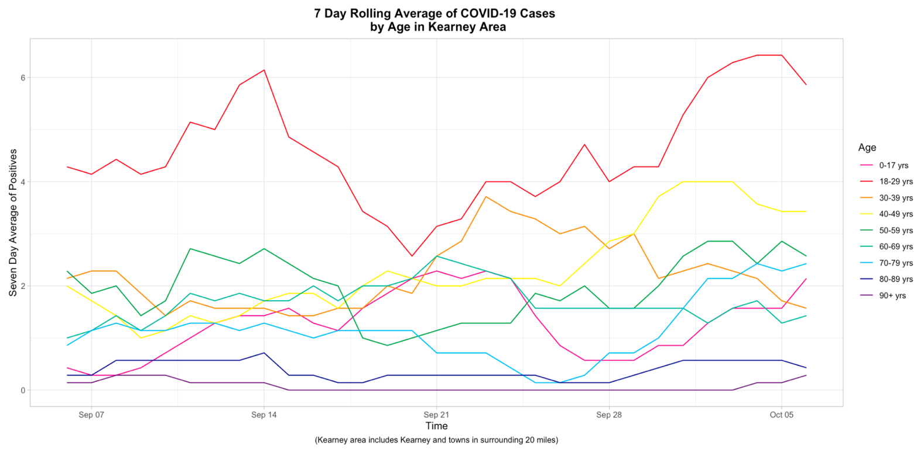
Table 1: Persons tested in Kearney area by gender and city of residence: Sep 6 – Oct 6
Age (in yrs) | Persons tested | Positive results | Positivity Rate
0-4 yrs | 55 | 5 | 9.1%
5-10yrs | 78 | 6 | 7.7%
11-13 yrs | 74 | 3 | 4.1%
14-17 yrs | 152 | 27 | 17.8%
18-23 yrs | 425 | 90 | 21.2%
24-29 yrs | 292 | 52 | 17.8%
30-39 yrs | 377 | 66 | 17.5%
40-49 yrs | 325 | 70 | 21.5%
50-59 yrs | 319 | 56 | 17.6%
60-69 yrs | 272 | 44 | 16.2%
70-79 yrs | 181 | 38 | 21.0%
80-89 yrs | 150 | 13 | 8.7%
90+ yrs | 106 | 3 | 2.8%
Total | 2806 | 473 | 16.9%

Mitigation measures
A significant body of evidence has emerged over the previous 6 months regarding continued support for mitigating measures for SARS-CoV2 proposed by public health. Mitigating the spread requires individuals, communities, and state public health actions to prevent person-to-person transmission.
Significant community mitigating measures include:
- Wearing face masks
- Social distancing
- Reducing the number and size of large gatherings
- Pausing operation of businesses when social distancing is challenging
- Working or staying at home
- Implementing additional workplace and educational controls
Specific recommendations for the Kearney area include increasing the adherence to face masks through a mask mandate, reduction in the number and size of large gatherings, and encouraging businesses to implement remote options when possible or other institutional controls (e.g. face coverings, distancing, staggered schedules).

