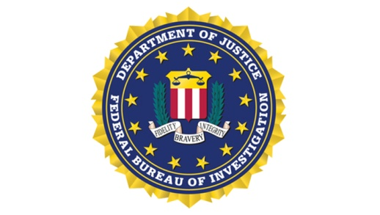
U.S. Department of Justice Federal Bureau of Investigation
Omaha Field Office
4411 South 121st Court
Omaha, NE 68137

FOR IMMEDIATE RELEASE FBI OMAHA, PUBLIC AFFAIRS June 17, 2019 Michele Stevenson
(402) 530-1132

FBI OMAHA SEEKING INFORMATION ON THE DISAPPEARANCE OF
SUNNY SRAMEK

OMAHA, NE – Sunny Sramek, age 18, was last seen on April 20, 2019 in Trenton, NE. Sramek was reported missing to the Hitchcock County Sheriff’s Office on April 21, 2019, by her mother. She was last seen riding in a 2004 White Ford Explorer bearing Iowa license plate HGJ-341. There have been no reported sightings of or contacts from Sramek since her disappearance.

Sramek is described as follows:
▪ Race: Caucasian
▪ Sex: Female
▪ Age: 18
▪ Height: 5ft. 8 inches
▪ Weight: 183 lbs.
▪ Hair: Brown
▪ Eye Color: Blue

Individuals with information concerning the disappearance of Sunny Sramek should immediately contact the Omaha Division of the FBI at (402) 493-8688.

####

