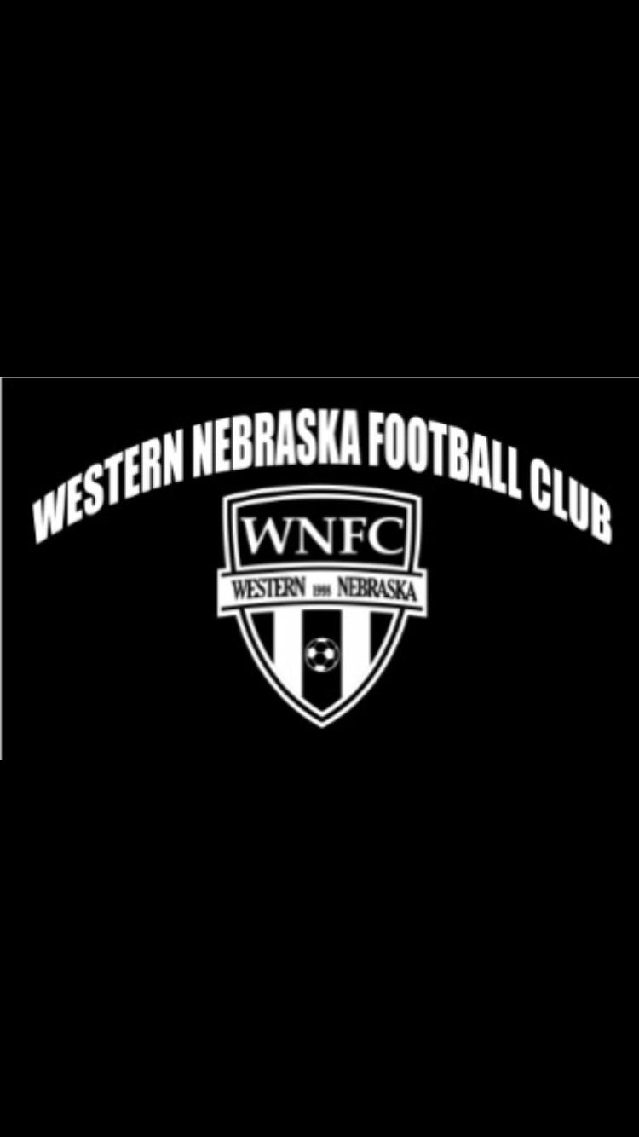

***For more information, visit:***

*www.ayso875.org*

*Kosha Johnson308-641-8561,Ruth Johnson 308-631-0778*

Fall Boys and Girls ages 3- High School**Registration Online:**

www.ayso875.org **Cost- Playground(3-5) Motor skill Development:** **$47.50Cost- Schoolyard(4)-8U: $57.50**

**Cost – 10U-High School: $62.50**

Fees includes a jersey,AYSO Membership, PLAYSOCCER Magazine,and supplemental accident insurance. **Season Dates:**

* **8U and below games/activities from September 8- October 13th**
* **10u and above September 8th – October 27th.**

**Additional information**

* 13-15U will be coed and separate from High School
* High School division will be coed and may play on an alternate day.

The American Youth Soccer Organization is a volunteer, non-profit program dedicated to providing children with a positive sports experience in a fun, safe, and fair environment. Volunteer Coaches and referees are offered training clinics to assist in developing your child’s knowledge of soccer and sportsmanship.