Real Estate Auction
For the Glenda Stokes Estate - Everett L. Stump P.R.
Saturday, April 14th, 2018 - 2:00 P.M.
Wagon Wheel Inn - 309 Ogden St., Oxford, NE
Auctioneer's Note: At this time to settle the Glenda Stokes Estate, the “Wagon Wheel Inn” is being offered at public auction. This property has been a tavern/coffee shop meeting establishment for the local folks for several years in downtown Oxford. The property is well located, has history with the community and has great potential to be active again. Make plans to take a walk through.
Open House: Saturday, April 7th, 2018 - 10:00 A.M. to 11:30 A.M.
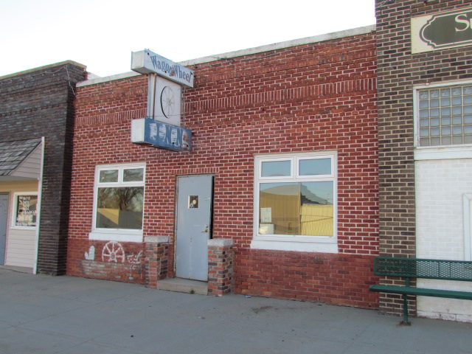
Parcel No.: 0004453.00
Address: 309 Ogden St. Oxford, NE.
Legal: 5×40' of LT 11 & All 12 BLK 35
Original Town Oxford Commercial, Furnas County, NE.
Year Built: 1930
Building Size: 1,200 Sq. Ft.
Zoned: Commercial
Real Estate Taxes: 2017's $248.84
Lot - 12 -Width: 25'
Lot - 12 -Depth: 150'
Lot - 11 is a partial lot, 5'x40'
TITLE: A Title Insurance commitment showing good title will be provided. The cost of title insurance and escrow will be divided equally between Buyer and Seller. (50/50)
POSSESSION: Upon closing to be held on or before Friday, April 27th, 2018.
TERMS: Offered on a cash basis only. NO Contingencies. Buyer will make a 20% deposit with the signing of the purchase agreement immediately following the Auction. The remainder shall be due on or before Friday, April 27th, 2018. A letter of credit from your banker will be required.
INFORMATION: Information has been obtained from sources believed to be reliable, although its accuracy can not be guaranteed by Seller and its agents. We urge prospective buyers to inspect and rely on their own conclusions over written material.
AGENCY: Mark Schipporeit - REALTOR, Days Auction & Realty and its agents are representing the Sellers. (Seller's Agents)
Days Auction & Realty not responsible for any accidents should any occur.
Auction Conducted by:
Days Auction & Realty
Doug Day - Broker
6205 2nd Ave., Ste. #2 Kearney, NE 68847
Office: (308) 234-6966
www.daysauctionrealty.com

