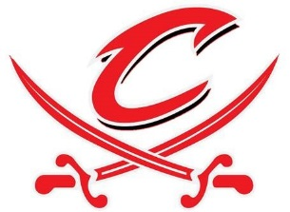
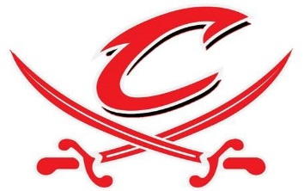
TIP NIGHT FOR CLOSE UP STUDENTS
To learn more visit: www.closeup.org
WHO: 15 local students are headed to Washington D.C. and New York City June 3rd-10th to learn and experience the exciting history and heritage of our great nation.

WHAT: These students will be waiting tables and helping out the staff at West Point Pizza Hut to earn tips which will help them pay for their trip.
WHEN: Wednesday, January 24th From 6 p.m. – 8 p.m. West Point Pizza Hut will donate 20% of all proceeds dine-in or carry out to the Close-Up trip participants.
Address: 136 E 13th St, West Point, NE 68788
Phone: (402) 372-5728

